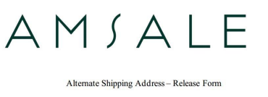Date: _03/10/25_

Store Name: _Bella Chicago_

I hereby request you to fulfill order #________________ by delivering the bridesmaid’s order therein referenced directly to the customer, _______________, in such manner that she may designate.

Customer Information

Kyla Barranco

1542 MLK Jr St SE,

Grand Rapids, Michigan 49506,

kyla.barranco@gmail.com,

(708)843-1494

I hereby release Amsale Aberra LLC, its affiliates, officers and employees from any obligation or liability whatsoever in connection with this order.

*erin wolf, 03/10/25*