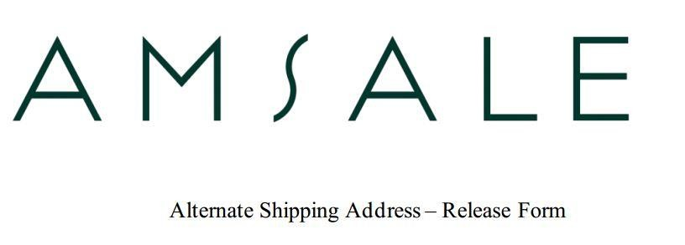

Date: 06/17/25

Store Name: Bella Chicago

I hereby request you to fulfill order # MO080925 by delivering the bridesmaid’s order therein referenced directly to the customer, Meghan Hopkins, in such manner that she may designate.

Customer Information

Meghan Hopkins
3600 N Lake Shore Dr
Apt 1501
Chicago, IL 60613
meghanelizabethhopkins@gmail.com
847-736-0757

I hereby release Amsale Aberra LLC, its affiliates, officers and employees from any obligation or liability whatsoever in connection with this order.

Signature

Erin Wolf

Date

06/17/25

